|  |  |
| --- | --- |
| \\VFILERDPI\DPI-Home\OBRIENR2\My Documents\Downloads\PP logo.jpg | Central Coast Council Logo |
| **ADDENDUM TO COUNCIL ASSESSMENT REPORT**  HUNTER AND CENTRAL COAST REGIONAL PLANNING PANEL | |

|  |  |
| --- | --- |
| **PANEL REFERENCE & DA NUMBER** | PPSHCC-290 – Central Coast – DA/320/2024 – 2 & 4 Brownlee Street, Ourimbah, 2258 |
| **PROPOSAL** | Construction of Light Industrial Building (Nine Units) |
| **ADDRESS** | Lot 3 DP612071, 2 Brownlee Street, Ourimbah  Lot 4 DP1237817, 4 Brownlee Street, Ourimbah |
| **APPLICANT** | Central Coast Industry Connect C/- Interface Planning |
| **OWNER** | Central Coast Council |
| **DA LODGEMENT DATE** | 10 April 2024 |
| **APPLICATION TYPE** | Development Application – Nominated Integrated & Integrated |
| **REGIONALLY SIGNIFICANT CRITERIA** | Clause 3, Schedule 6 of *State Environmental Planning Policy (Planning Systems) 2021:* Council related development over $5 million |
| **CIV** | $10,546,126 (excluding GST) |
| **CLAUSE 4.6 REQUESTS** | N/A |
| **KEY SEPP/LEP** | *SEPP (Planning Systems) 2021*  *SEPP (Transport and Infrastructure) 2021*  *SEPP (Resilience and Hazards) 2021*  *SEPP (Biodiversity and Conservation) 2021*  *SEPP (Sustainable Buildings) 2022*  *Central Coast Local Environmental Plan 2022*  *Central Coast Development Control Plan 2022* |
| **TOTAL & UNIQUE SUBMISSIONS KEY ISSUES IN SUBMISSIONS** | Two submissions |
| **DOCUMENTS SUBMITTED FOR CONSIDERATION** | Council Assessment Report and Attachments 1 – 7:  Attachment A: Draft conditions of consent  Attachment B: Table of Compliance (CCDCP Chapter 2.9)  Attachment C: Statement of Environmental Effects  Attachment D: Architectural Plans  Attachment E: Civil Plans  Attachment F: Flood Impact and Risk Assessment |
| **SPECIAL INFRASTRUCTURE CONTRIBUTIONS (S7.24)** | N/A |
| **RECOMMENDATION** | Approval |
| **DRAFT CONDITIONS TO APPLICANT** | Yes |
| **SCHEDULED MEETING DATE** | 15 October 2024 |
| **PLAN VERSION** | 24 September 2024 |
| **PREPARED BY** | Jenny Tattam |
| **DATE OF ORIGINAL REPORT** | 3 October 2024 |
| **DATE OF REPORT** | 3 December 2024 |

**EXECUTIVE SUMMARY**

Development Application No. DA/320/2024 has been submitted on behalf of Central Coast Industry Connect Limited (CCIC) seeking consent to construct a light industrial building containing nine units to be used as a Food Manufacturing Hub. The facility will be a co-operative hub for food manufacturing research, innovation, promotion, and education.

The purpose of this addendum is to address the additional information requested by the Hunter & Central Coast Regional Planning Panel following deferral of DA/320/2024 (PPSHCC-290) on 18 October 2024. The reason for deferral was to request further information from the applicant regarding issues identified during the determination meeting.

Additional information has been submitted by the applicant to address the matters raised by the Panel in the Record of Deferral.

The additional information has been assessed, with regard to the matters raised by the Panel in the Record of Deferral and under Section 4.15 of the EP&A Act and is considered satisfactory. The recommended conditions of consent have been updated to reflect the amendments made to the proposal. Accordingly, it is recommended that the application be approved subject to the amended draft conditions of consent.

**RECOMMENDATION**

That Development Application No. 320/2024 for Light Industrial Building (Nine Units) at 2 & 4 Brownlee Street, Ourimbah be APPROVED pursuant to Section 4.16(1)(a) of the *Environmental Planning and Assessment Act 1979* (EP&A Act) subject to the amended draft conditions of consent.

**INTRODUCTION**

This addendum report provides a detailed overview of the additional information submitted by the applicant to address the Panel’s reasons for deferral dated 18 October 2024.

**BACKGROUND**

In their deferral notice the Panel requested the following further information from the applicant:

1. *Sufficient information to satisfy the provisions of section 4.6 of SEPP (Resilience and Hazards) 2021;*
2. *A Remediation Action Plan;*
3. *Details of the impact on the Landscape Plans and the Bushland Management Plan of any remediation strategy (if any); and*
4. *A Flood Emergency Response Plan*

**AMENDED PROPOSAL**

Additional information has been submitted in response to the matters raised by the Panel. The additional information includes:

* Revised Detailed Site Investigation
* Remediation Action Plan
* Flood Emergency Response Plan

The applicant provided a formal written request to amend the application in accordance with Section 37 of the *Environmental Planning and Assessment Regulation 2021* on 26 November 2024. This amendment was accepted.

**PLANNING ASSESSMENT**

This revised assessment considers only those matters relevant to the reasons for deferral. The remaining assessment remains unchanged from the original Council Assessment Report dated 3 October 2024.

1. *Sufficient information to satisfy the provisions of section 4.6 of SEPP (Resilience and Hazards) 2021*

Under Section 4.6 of SEPP (Resilience and Hazards) 2021 a consent authority must not consent to the carrying out of any development on land unless it has considered whether the land is contaminated, and if the land is contaminated, it is satisfied that the land is suitable in its contaminated state (or will be suitable, after remediation) and if the land requires remediation to be made suitable for the proposed use, it is satisfied that the land will be remediated before the land is used for that purpose.

The site has previously been used for commercial/industrial uses and in accordance with Section 4.6 the applicant prepared a Preliminary Site Investigation (PSI). The PSI identified four Areas of Environmental Concern (AECs) for the site relating to:

1. Former sawmill/recycling depot;

2. Former use of Lot 42 as Council depot;

3. Abandoned dwelling on Lot 42; and

4. Fill materials.

Based on the site history and observations, it was recommended that a Detailed Site Investigation (DSI) was carried out. The DSI detailed the following work that was carried out – excavation of 11 test pits, and collection of soil samples from 8 test pit locations, and 18 surface soil locations. The laboratory results reported concentrations below the adopted criteria. The DSI noted the following:

*It is noted that two areas of the site where AECs are present: former office building on the western boundary, and a former waste/recycling area on the eastern portion of the site, were inaccessible due to thick vegetation.*

In their deferral notice, the Panel noted the following:

*The Panel is not satisfied that there is sufficient information to satisfy the provisions of section 4.6 of SEPP (Resilience and Hazards) 2021. Furthermore, it is unclear what, if any, remediation strategy is required for these areas, and whether it will impact upon the Landscape Plans and the Bushland Management Plan lodged with the application.*

In accordance with the Panel’s notice of deferral the applicant undertook additional sampling on 25 October 2024. The sampling included an additional 16 test pits and one surface sample within the following areas of environmental concern that were previously identified in the DSI as being inaccessible:

* Former sawmill oil store, former sawmill waste area, former sawmill storage shed, former waste storage areas and areas subject to potential fill material.

Sampling was also conducted in the southern portion of the site which was not previously included.

The sampling was carried out following minor weed clearance. The sampling locations are shown in the following figures – the yellow icons denote the additional testing locations carried out on 25 October 2024.

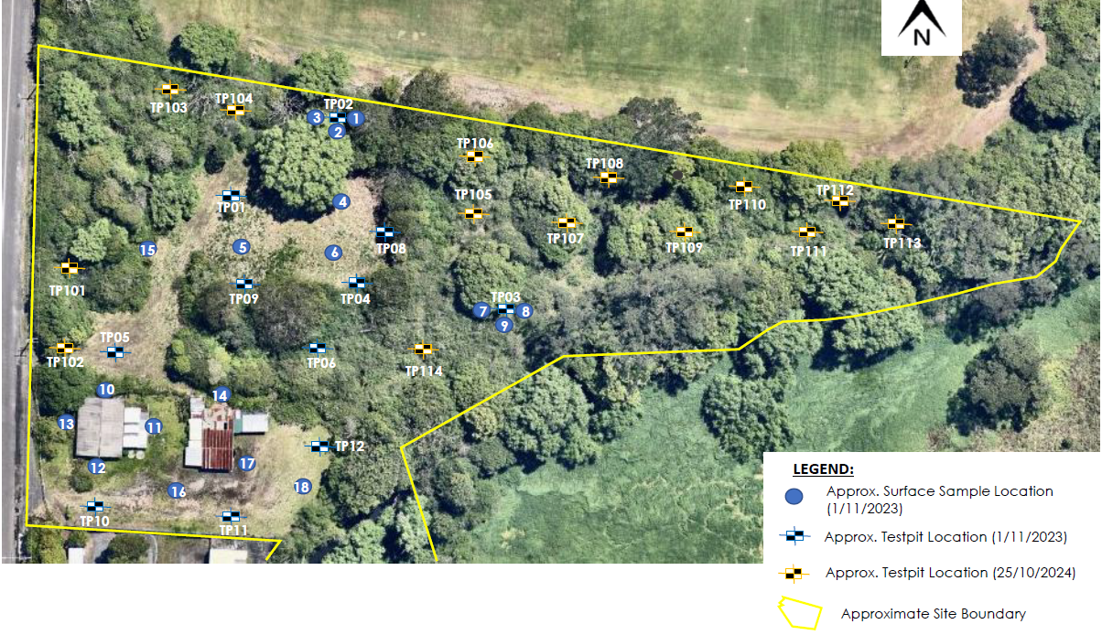

*Figure 1: Sample Plan - Northern Portion of the Site*

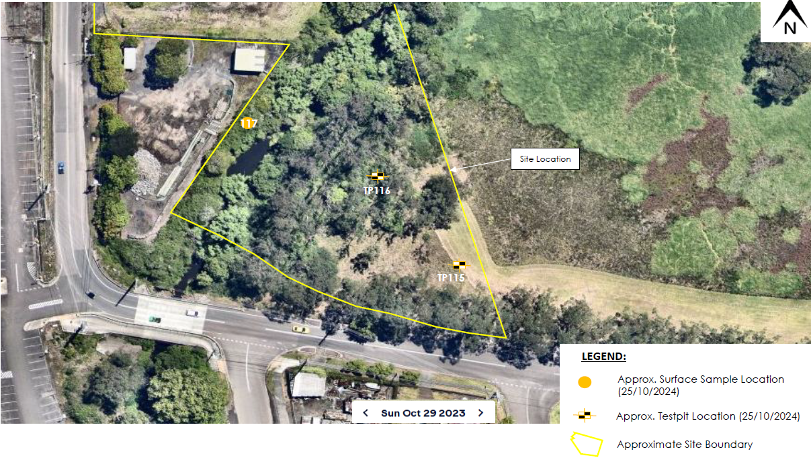

*Figure 2: Sample Plan - Southern Portion of the Site*

A revised DSI (dated 22 November 2024) was submitted on 26 November 2024 and has been reviewed by Council’s Principal Environmental Specialist.

All samples were analysed for all potential contaminants of concern and were below the human health adopted soil assessment criteria. Most samples identified anthropogenic materials including trace fragments of bricks, glass, metal, plastic, pvc, timber and charcoal. One sample was elevated above the ecological adopted soil assessment criteria for copper in the east of the site (TP111) and potential asbestos fragments were found on the surface of one test pit around the former sawmill office area in the west of the site (test pit 101).

The location of the sample which returned the elevated copper level above the ecological adopted soil assessment criteria, is within the former waste area which is located within the riparian zone and vegetated areas of the proposed development (TP111, circled in purple, Figure 3). No signs of vegetation stress were observed, and it is proposed the area is not subject to be developed, or excavated, with the only activity for the proposed development comprising of clearing of weeds. It is proposed that remediation of the copper would pose a net adverse environmental impact, as it would require clearing of vegetation, and excavation and disposal of soils to landfill. Based on this the copper does not pose a risk to ecological or human receptors and remediation of the copper is not required.

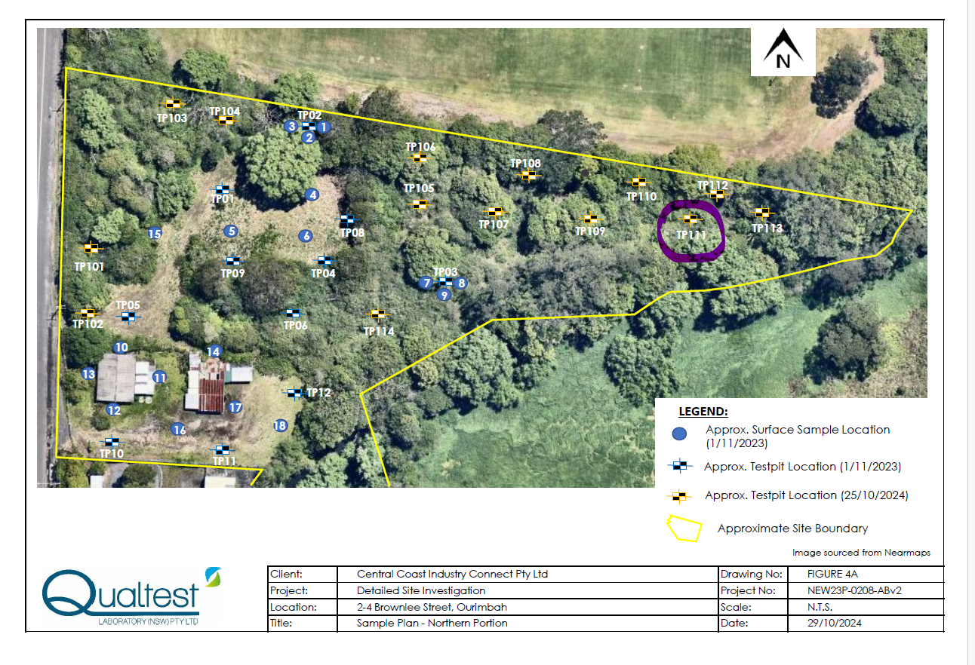

*Figure 3: Shows the location of TP111, circled in purple*

Regarding the potential asbestos fragments the DSI provided the following recommendations:

* Preparation and implementation of a Remediation Action Plan (RAP) for remediation of the identified asbestos containing material (ACM) contamination.
* Preparation and implementation of an Asbestos Management and Removal Control Plan (AMRCP) would be required for the handling and disposal of ACM or ACM impacted soils.
* Preparation and implementation of an Unexpected Finds Procedure. It is recommended that an environmental scientist is present during vegetation clearing and excavations for the proposed detention basin and associated drainage lines.

The DSI concludes that provided the above recommendations are implemented, it is considered that the site could be rendered suitable, from a contamination point of view, for the proposed Manufacturing Food Hub development.

A Remediation Action Plan (RAP) has been developed and is further discussed below. Conditions of consent require that site contamination remediation works are carried out in accordance with the RAP, the AMRCP and Unexpected Finds Protocol (**conditions 2.21, 4.6, 4.7**). A further condition requires preparation of a Validation Report following completion of the remediation works (**condition 4.8**).

It is considered that the Applicant has provided sufficient information to satisfy the provisions of section 4.6 of SEPP (Resilience and Hazards) 2021 and the Panel can be satisfied the land is suitable for the proposed development.

1. *A Remediation Action Plan*

The applicant has prepared a Remediation Action Plan (RAP) prepared by Qualtest, dated 5 November 2024. The goal of the RAP is to remediate the site to a condition such that it is suitable for the proposed Food Manufacturing Hub. The RAP states that the contamination that needs to be remediated and/or managed is the bonded Asbestos Containing Materials (ACM) found on the site surface in sample location TP101 located in the former office area – central western portion of the site (as shown in the figure below).

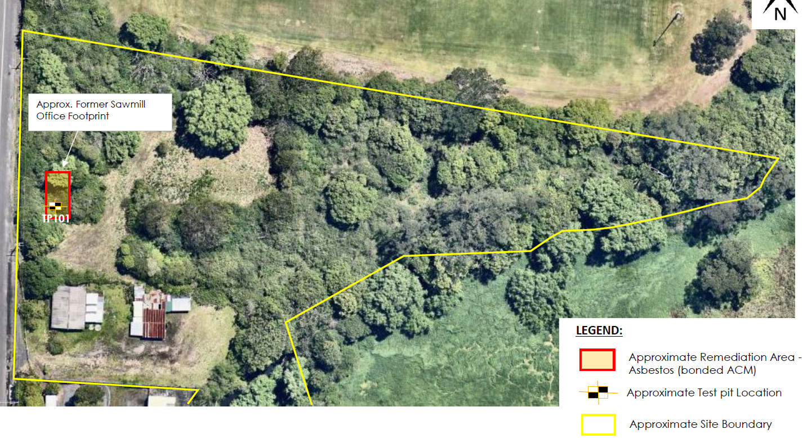

*Figure 4: Expected Remediation Area*

The RAP proposes offsite disposal of the asbestos detected in surface soils around the former sawmill office area, along with the implementation of an unexpected finds protocol (it is recommended that an environmental scientist is present during vegetation clearing and excavations for the proposed detention basin and associated drainage lines), as well as the preparation and implementation of an Asbestos Management and Removal Control Plan (AMRCP) and the preparation of a Validation Report following completion of the remediation works.

Conditions have been applied requiring implementation of the RAP, AMRCP, and the unexpected finds protocol and the preparation of a Validation Report.

1. *Details of the impact on the Landscape Plans and the Bushland Management Plan of any remediation strategy (if any)*

As outlined above the further sampling conducted on 25 October 2024 identified copper contamination exceeding the ecological investigation level (EIL) at test pit location TP111 within the former sawmill waste area (north-eastern portion of the site). The test pit encountered timber, bricks and metals, where the copper was considered likely to be due to a fragment of metal and localised. The area surrounding TP111 was densely vegetated, and no signs of vegetation stress were observed. These areas are not proposed to be disturbed by the development and it was considered that remediation of the copper would pose net adverse environmental impact (vegetation clearing, and excavation and disposal to landfill). Based on this the copper does not pose a risk to the ecological or human receptors.

In summary the DSI considers that it is safe to both the environment and humans to leave the copper in the ground where it was found, and no remediation actions are required. On this basis there is no impact to the proposed Landscape Plan and Bushland Management Plan.

1. *A Flood Emergency Response Plan*

The applicant has provided a Flood Emergency Response Plan (FERP), prepared by Northrop, dated 15 October 2024.

The site is subject to flooding from Bangalow Creek which traverses the eastern side of the site. The FERP provides a description of flood behaviour and the site affectation, reviews available flood warnings for the area and details key emergency management considerations and actions to be undertaken before, during and after a flood emergency to keep occupants safe.

To minimise the risk to life, the FERP recommends that the facility be closed if a generalised flood warning or severe weather warning is received with nominated rainfall depth equivalent to a 1% AEP flood event. The aim is to eliminate/reduce the risk to life by removing as many staff and visitors from the floodplain prior to the commencement of rainfall.

If flooding occurs and people are unable to return home controlled evacuation should occur to the nominated off-site refuge. If it is deemed impossible to seek refuge at the designated off-site refuge point, refuge may be sort on-site on Level 1 of the facility.

The Flood Emergency Response Plan was referred to Council’s Development Flooding Engineer for review and comment. They have advised that the FERP is satisfactory, and a condition of consent is recommended to ensure adherence to the FERP (**condition 6.14**).

Council’s Development Flooding Engineer has confirmed that he is satisfied that both Clause 5.21 Flood Planning and Clause 5.22 Special Flood Considerations of Central Coast LEP have been adequately addressed.

***Environmental Planning and Assessment Act 1979* (*EP&A Act)***

***Section 4.15 Evaluation***

***Section 4.15(1)(a)(i) provisions of any environmental planning instrument***

The amended development is consistent with the provisions of the Central Coast Local Environmental Plan 2022 (CCLEP) and the following SEPPs applicable to the proposal:

* [*State Environmental Planning Policy (Planning Systems) 2021*](https://legislation.nsw.gov.au/view/html/inforce/current/epi-2021-0724)
* [*State Environmental Planning Policy (Biodiversity and Conservation) 2021*](https://legislation.nsw.gov.au/view/html/inforce/current/epi-2021-0722)
* [*State Environmental Planning Policy (Resilience and Hazards) 2021*](https://legislation.nsw.gov.au/view/html/inforce/current/epi-2021-0730)
* *State Environmental Planning Policy (Sustainable Buildings) 2022*
* [*State Environmental Planning Policy (Transport and Infrastructure) 2021*](https://legislation.nsw.gov.au/view/html/inforce/current/epi-2021-0732)
* *Central Coast Local Environmental Plan 2022*

In regard to SEPP (Resilience and Hazards) 2021 the Panel can be satisfied that the provisions of section 4.6 have been met. The applicant has provided further information to confirm the land is contaminated and as a result has prepared a Remediation Action Plan (RAP). A condition of consent requires that the land will be remediated in accordance with the RAP.

In regard to CCLEP 2022 the Panel can be satisfied that:

* Clause 5.21 – Flood planning

The proposed development:

1. *is compatible with the flood function and behaviour on the land, and*
2. *will not adversely affect flood behaviour in a way that results in detrimental increases in the potential flood affectation of other development or properties, and*
3. *will not adversely affect the safe occupation and efficient evacuation of people or exceed the capacity of existing evacuation routes for the surrounding area in the event of a flood, and*
4. *incorporates appropriate measures to manage risk to life in the event of a flood, and*
5. *will not adversely affect the environment or cause avoidable erosion, siltation, destruction of riparian vegetation or a reduction in the stability of river banks or watercourses.*

* Clause 5.22 – Special flood considerations

Subject to recommended conditions of consent, the development will not affect the safe occupation of, and evacuation from, the land during flood events exceeding the flood planning level.

***Section 4.15(1)(a)(ii) any draft environmental planning instrument that is or has been placed on public exhibition***

There are no draft instruments relevant to the amended proposal.

***Section 4.15(1)(a)(ii) any development control plan (and section 7.11 plan)***

The proposal remains consistent with the provisions of the Central Coast Development Control Plan 2022 (DCP).

***Section 4.15(1)(a)(iia) Planning agreements***

There are no planning agreements that are relevant to the proposed development.

***Section 4.15(1)(a)(iv) the regulations (and other plans and policies)***

There are no matters within the regulations that are relevant to the supplementary information.

***Section 4.15(1)(b) the likely impacts of the development, including environmental impacts on both the natural and built environments, and social and economic impacts in the locality***

The likely environmental impacts of the development relating to the natural and built environments, and social and economic impacts remain generally unchanged from that identified in the original Council Assessment Report of 3 October 2024.

***Section 4.15(1)(c) the suitability of the site for the development***

The site is suitable for the amended development for the reasons identified within the original Council Assessment Report of 3 October 2024.

***Section 4.15(1)(d) any submissions made in accordance with this act or the regulations***

The amended proposal does not involve any substantial change to environmental impacts or material changes from those plans originally notified. Accordingly, no further re-notification or advertising is required.

***Section 4.15 (1)(e) the public interest***

The amended proposal is considered to be in the public interest for the reasons identified within the Council Assessment Report of 3 October 2024.

**Attachments:**

1. Revised recommended conditions of consent
2. Revised Detailed Site Investigation (Qualtest, 22 November 2024)
3. Remediation Action Plan (Qualtest, 5 November 2024)
4. Flood Emergency Response Plan (Northrop, 15 October 2024)
5. Applicant’s letter dated 26 November 2024